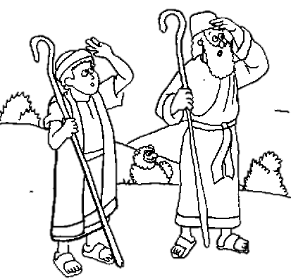

The Angel’s Message of Peace for the Shepherds

**Scripture Reference:**

Luke 2:8-14, Matthew 1:18-25

December 11, 2016

Big Picture: The Gifts of Christmas

**Big Point:** God gives us peace.

**Bible Verse:**

“May the God of hope fill you with all joy and peace as you trust in him, so that you may overflow with hope by the power of the Holy Spirit.” - Romans 15:13