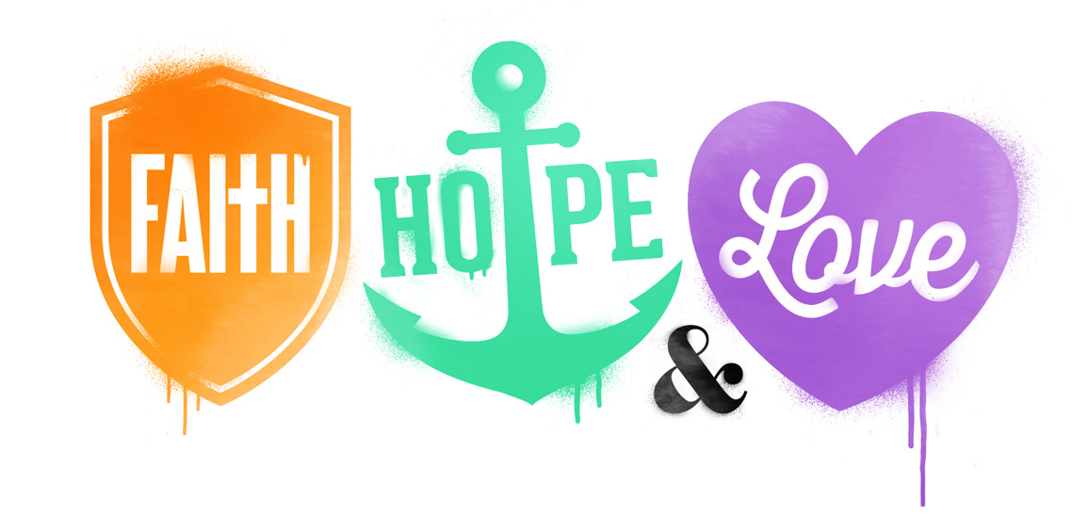

**Scripture Reference:**

Acts 16:16-40

February 5, 2017

**Big Point:** No matter what happens, living with hope brings joy!

**Bible Verse:**

“And now these three remain: faith, hope and love. But the greatest of these is love.” - 1 Corinthians 13:13

PRAISE REPORT! Write one thing you’ve thanked God for this week:

**Elementary Bible Study**

Grab your Bible and find a quiet space. Let’s discover what God has to say.

Choose one of the following passages: Nehemiah 8:10, Habakkuk 3:17-19, Romans 15:13, 2 Corinthians 6:10, 2 Corinthians 8:2, Philippians 2:17-18. Read the passage then use the space below to think about what God is teaching you.

Today I read: _________________________________________________________

It was all about: _______________________________________________________ ________________________________________________________________________________________________________________________________________

I learned that: ________________________________________________________ ________________________________________________________________________________________________________________________________________

My prayer: ___________________________________________________________ ________________________________________________________________________________________________________________________________________

Big Picture: Hope